**Software Requirements Specification (SRS)**

**Name of Proponents:** Barbacena, Angelo C.

Gasco, Donabel V.

Festin, Jeremy P.

Genteroy, Ezeckiel James V.

**Application Development Proposed Title:**

Campus Virtual Tour: An Engaging 3D Virtual Tour for Mindoro State University Calapan City Campus

**1. Introduction**

* 1. **Purpose:**

The 3D Virtual Tour for Mindoro State University Calapan City Campus primarily focuses on helping users navigate the campus effectively by serving as a virtual map. Designed to guide prospective students, visitors, instructor, staff and even current students, the system offers an immersive experience where users can explore the university's layout and locate key buildings and facilities with ease. The GPS-style interface allows users to find the most efficient routes to various campus locations, such as classrooms, offices, libraries, and recreational areas, ensuring that they can move around the campus confidently, even without prior knowledge of the grounds. By providing accurate, and interactive map of the campus, the system saves time and reduces confusion, offering a seamless and convenient navigation experience. This virtual guide serves as a practical tool for new students and visitors while enhancing overall accessibility and user satisfaction.

**1.2 Scope:**

The 3D Virtual Map for Mindoro State University Calapan City Campus aims to provide a comprehensive virtual representation of the entire campus, covering all buildings, facilities, and pathways. The system will offer users a detailed and accurate view of the campus layout, ensuring they can easily explore key areas such as academic buildings, administrative offices, recreational spaces, and student facilities. This virtual tour is designed to assist prospective students, visitors, and current students in familiarizing themselves with the campus, making navigation smoother and more intuitive.

**1.3 Overview:**

The project will create a simple, user-friendly virtual tour that helps users explore the campus. With a GPS-style map, users can easily find buildings, locate important facilities, and see the best routes between locations. The virtual tour will help prospective students, visitors, and current students get familiar with the campus, making it easier to navigate and explore. This tool will save time, reduce confusion, and make the university more accessible to everyone, whether they visit in person or online.

**2. General Description**

**2.1 Functions**

* 3D map for exploring the entire campus.
* Search function to quickly find buildings, departments, or facilities.
* Predefined tour routes for easy navigation.
* Clickable buildings display key details like hours of operation.
* Accessible on computers, tablets, and smartphones.

**2.2 User Community**

The primary users include prospective students, visitors, instructors, staff, and current students. They will use the system to explore the university layout and easily find key buildings and facilities.

**3.Functional Requirements  
3.1 Possible Outcomes**

* Easily find buildings and facilities, saving time.
* Engage prospective students and visitors, increasing interest.
* Help current users discover lesser-known campus areas.
* Enable remote users to explore the campus virtually.
* Provide clear directions, reducing search time.
* Create a positive first impression with a visual campus overview

**3.2 Ranked Order**

1. 3D Campus Navigation
2. Search and Locate Buildings/Facilities
3. Step-by-Step Directions
4. User Interaction and Information Display
5. Comment section for Feedback

**3.3 Input Output Relationship**

**Inputs:**

* Campus map data
* Building details (names, departments, operating hours)
* User location or selected starting point
* Search queries for buildings or facilities

**Outputs:**

* 3D interactive campus map
* Step-by-step navigation directions
* Detailed building information (hours, departments)
* Device-responsive virtual tour display

**4. User Interface requirements**

**4.1 Software Interfaces**

* User-friendly homepage with an interactive 3D campus map
* Search bar for finding buildings and facilities
* Navigation interface with step-by-step directions
* Responsive design for seamless use on computers, tablets, and smartphones

**4.2 Examples**

The interface will feature intuitive buttons for actions like searching for buildings, starting tours, and accessing navigation routes, ensuring easy use for students, instructors, visitors, and staff.

**5. Performance Requirements**

**5.1 Response Time**

The system should respond as quickly as possible to user actions, ensuring smooth and efficient operation.

**5.2 Throughput**

It must handle multiple users simultaneously, even during peak usage, without experiencing delays.

**5.3 Scalability**

The system should be able to expand as the university grows, accommodating more users, buildings, and features over time.

**6. Non-Functional Attributes**

**6.1 Usability**

The system should be easy to navigate, allowing users to quickly get familiar with the interface without needing extensive training..

**6.2 Reliability**

It should ensure high availability with minimal downtime, especially during high-traffic periods such as enrollment or campus events.

**6.3 Security**

Secure login with encrypted passwords and token-based authentication, along with role-based access control, will be implemented to protect user data and campus information.

**Design Document Specification (DDS)**

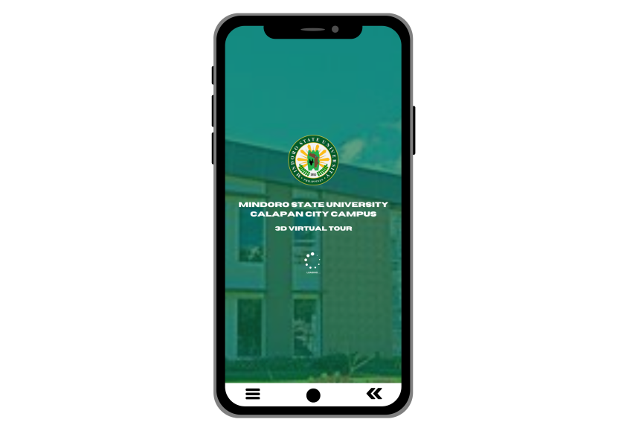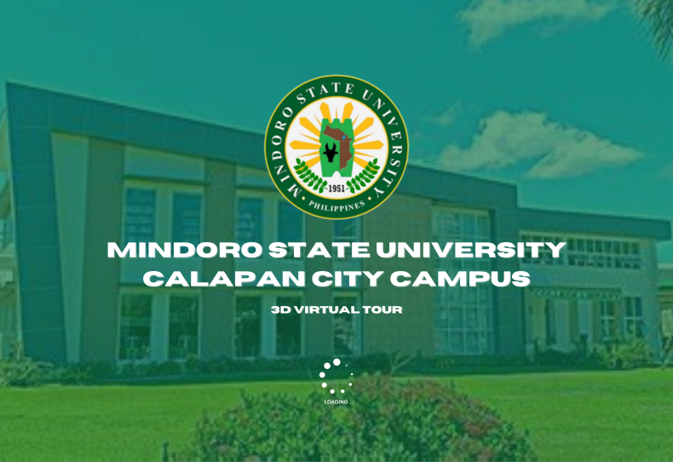

Figure 1. Loading page

The loading page of the 3D Virtual Tour for Mindoro State University Calapan City Campus. It presents the university's official logo prominently at the top, followed by the name "Mindoro State University Calapan City Campus" in bold text. Below, the text "3D Virtual Tour" specifies the function of the system, signaling that users are about to access the virtual tour. A loading icon is positioned at the bottom, indicating that the system is currently processing. The background features a key campus building, providing a visual introduction while the system loads.

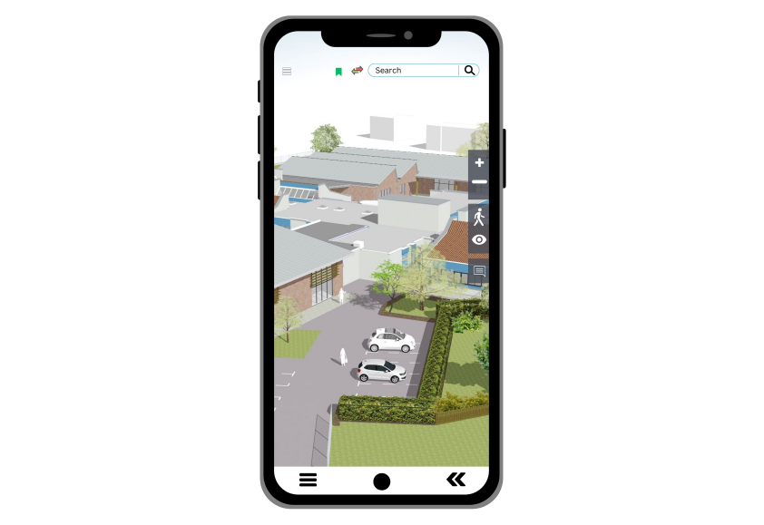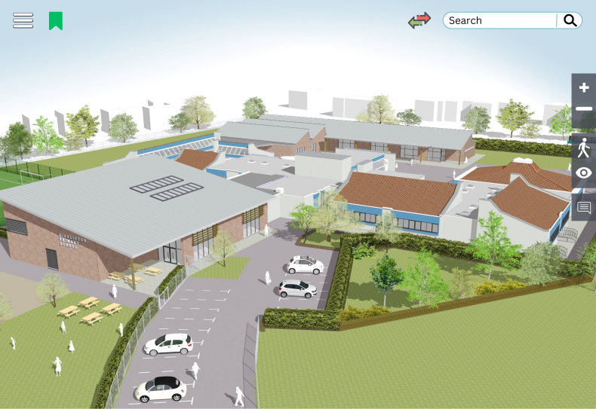

Figure 2. Homepage

The homepage of the 3D campus map includes several interactive elements and tools for easy navigation and exploration.

**Search Bar (Top-Right):**  
A search bar allows users to quickly find buildings, facilities, or locations by typing in specific names. This feature eliminates the need to manually browse the entire map.

**3D Map View (Main Area):**  
The main display presents a 3D rendering of the entire campus, showing buildings, parking lots, pathways, and greenery. Users can interact with the map by panning and zooming to explore different areas.

**Navigation Controls (Right-Side):**

**- Zoom In/Out Buttons (+/-):** Enable users to adjust their view of the map by zooming in for a closer look or zooming out for a wider view.

**- Walking Route Icon:** Provides walking path options and step-by-step directions for campus navigation on foot.

**- Eye Icon:** Allows users to switch to a bird's-eye view of the campus, offering a broader perspective from above to better understand the layout.

**- Comment Icon: A**llows users to leave feedback or suggestions about their experience with the virtual tour. This feature helps improve the system by gathering user input and addressing any issues or enhancements that may be needed.

**Bookmarks/Save Feature (Top-Left):**  
The green bookmark icon lets users save specific locations or buildings on the map for easy access later, reducing the need for repeated searches.

**Menu/Settings Icon (Top-Left Corner):**  
The three-bar menu icon (commonly referred to as the "hamburger menu") opens additional options like settings, predefined tours, or other navigation features.

**Location Pin and Destination Input (Top-Center):**  
This feature allows users to set their current location and input their desired destination. The system will then provide the most efficient route within the campus, helping users navigate quickly and easily between points.

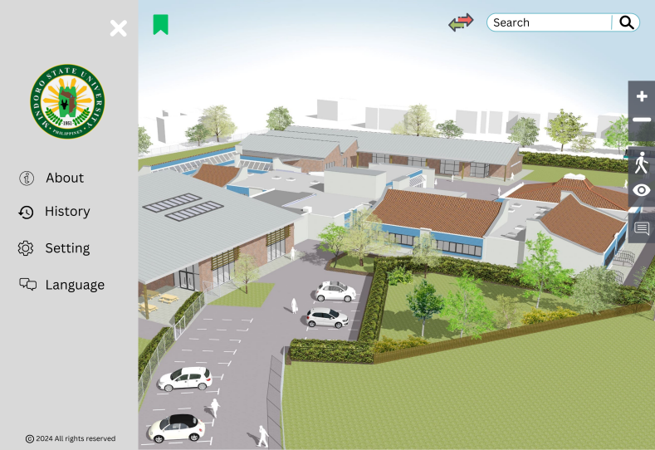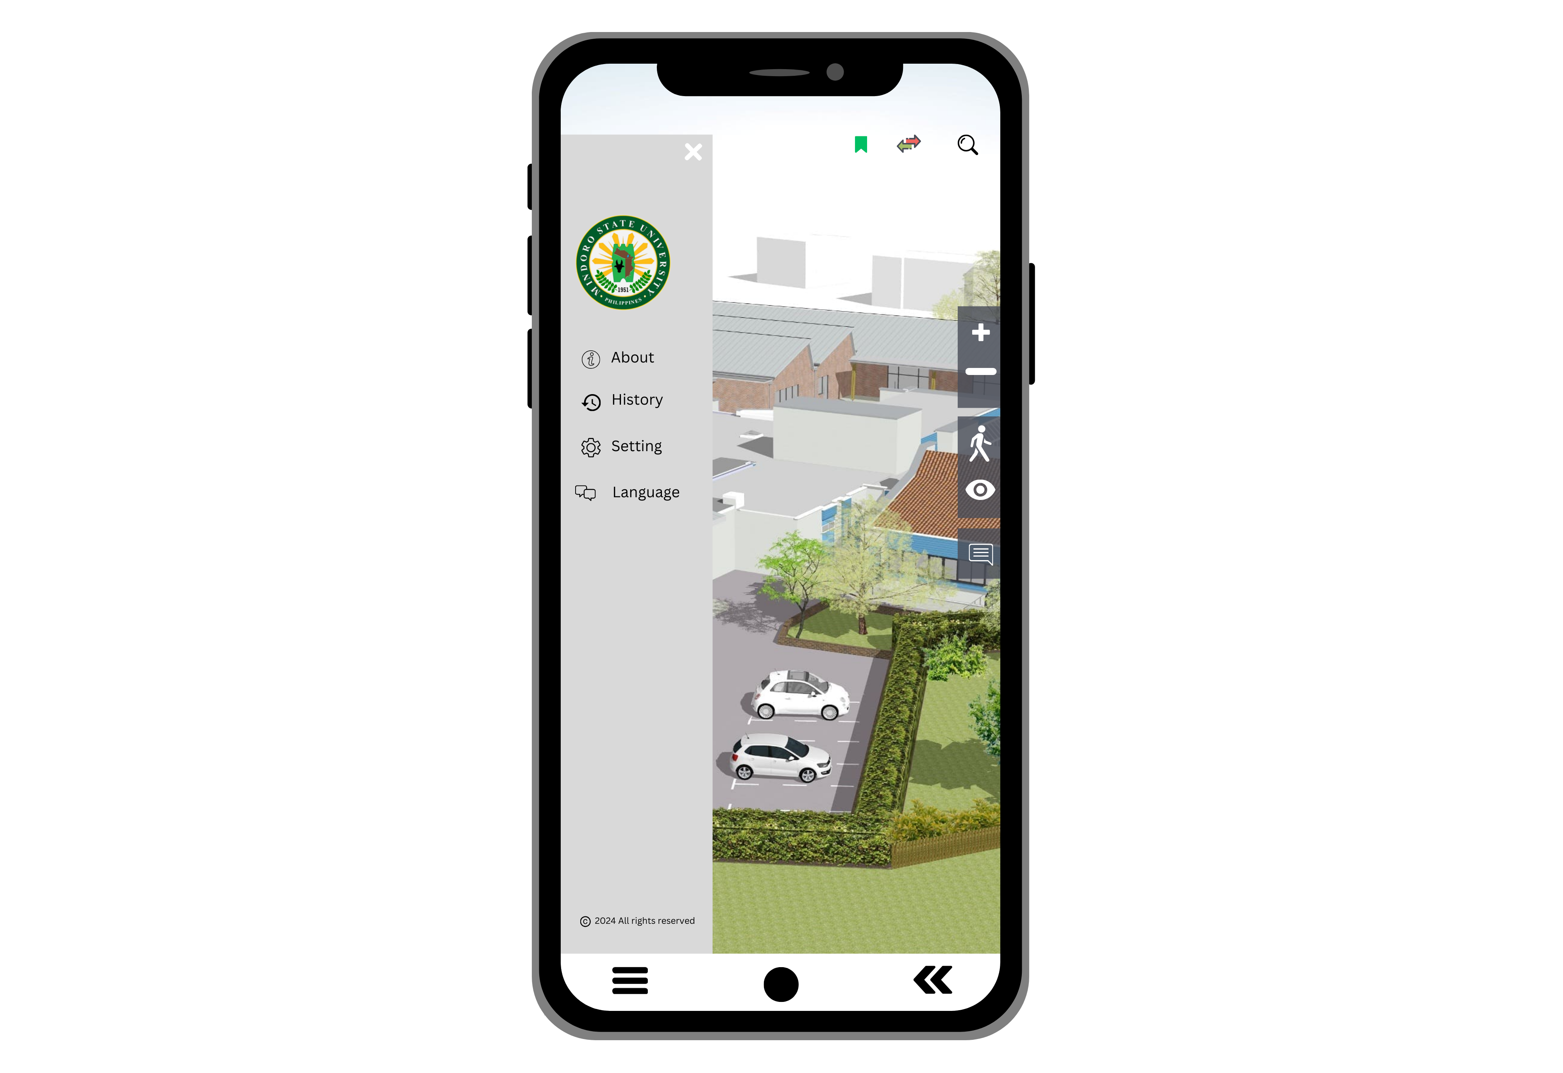

Figure 3. Menu button

The **menu page** of the 3D Virtual Tour for Mindoro State University Calapan City Campus serves as a central hub for user navigation and options. It features a clean and organized layout that includes various sections, such as:

**About**:  
This section showcase the **VMGO (Vision, Mission, Goals, and Objectives)** of the school along with a brief history. This will inform users about the institution's core values and its historical background, helping to provide context and significance for the virtual tour.

**History (Recent Searches)**:  
The History or Recent Searches section tracks and lists the most recent searches or interactions the user has had within the app. This feature allows users to easily revisit previous searches or locations within the virtual tour.

**Settings:**  
In the Settings section, users can customize various aspects of the app to better suit their preferences.

**Language (English and Filipino)**:  
This feature allows users to switch between English and Filipino languages. When toggled, it translates all text and interface elements into the selected language, ensuring accessibility and a better user experience for both English and Filipino-speaking users.